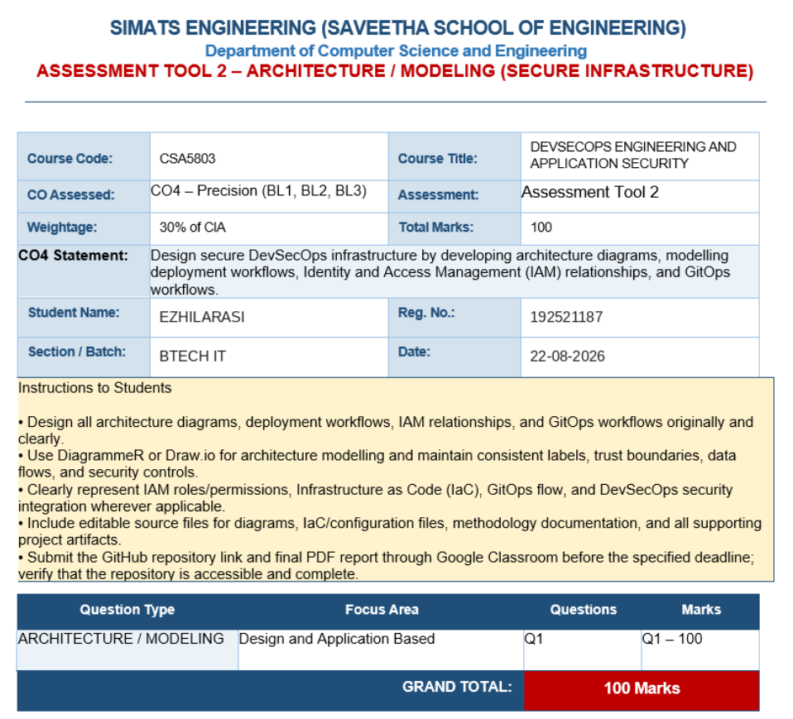

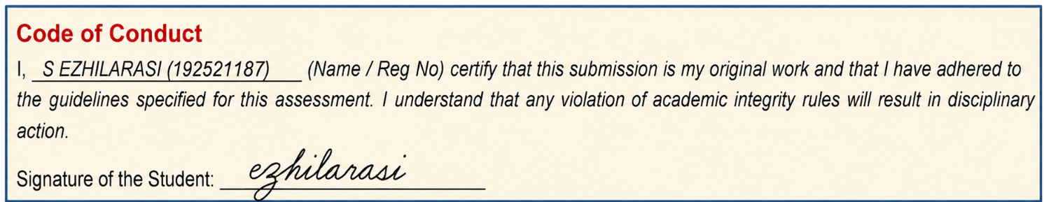

1. Design Objective
Design an original secure DevSecOps infrastructure that integrates application hosting, identity and access management, continuous integration, security testing, infrastructure/deployment automation and GitOps-based operations. The design must enforce trust boundaries, secure data flows, least privilege and continuous monitoring while keeping production changes auditable.

2. Proposed Secure Infrastructure Architecture
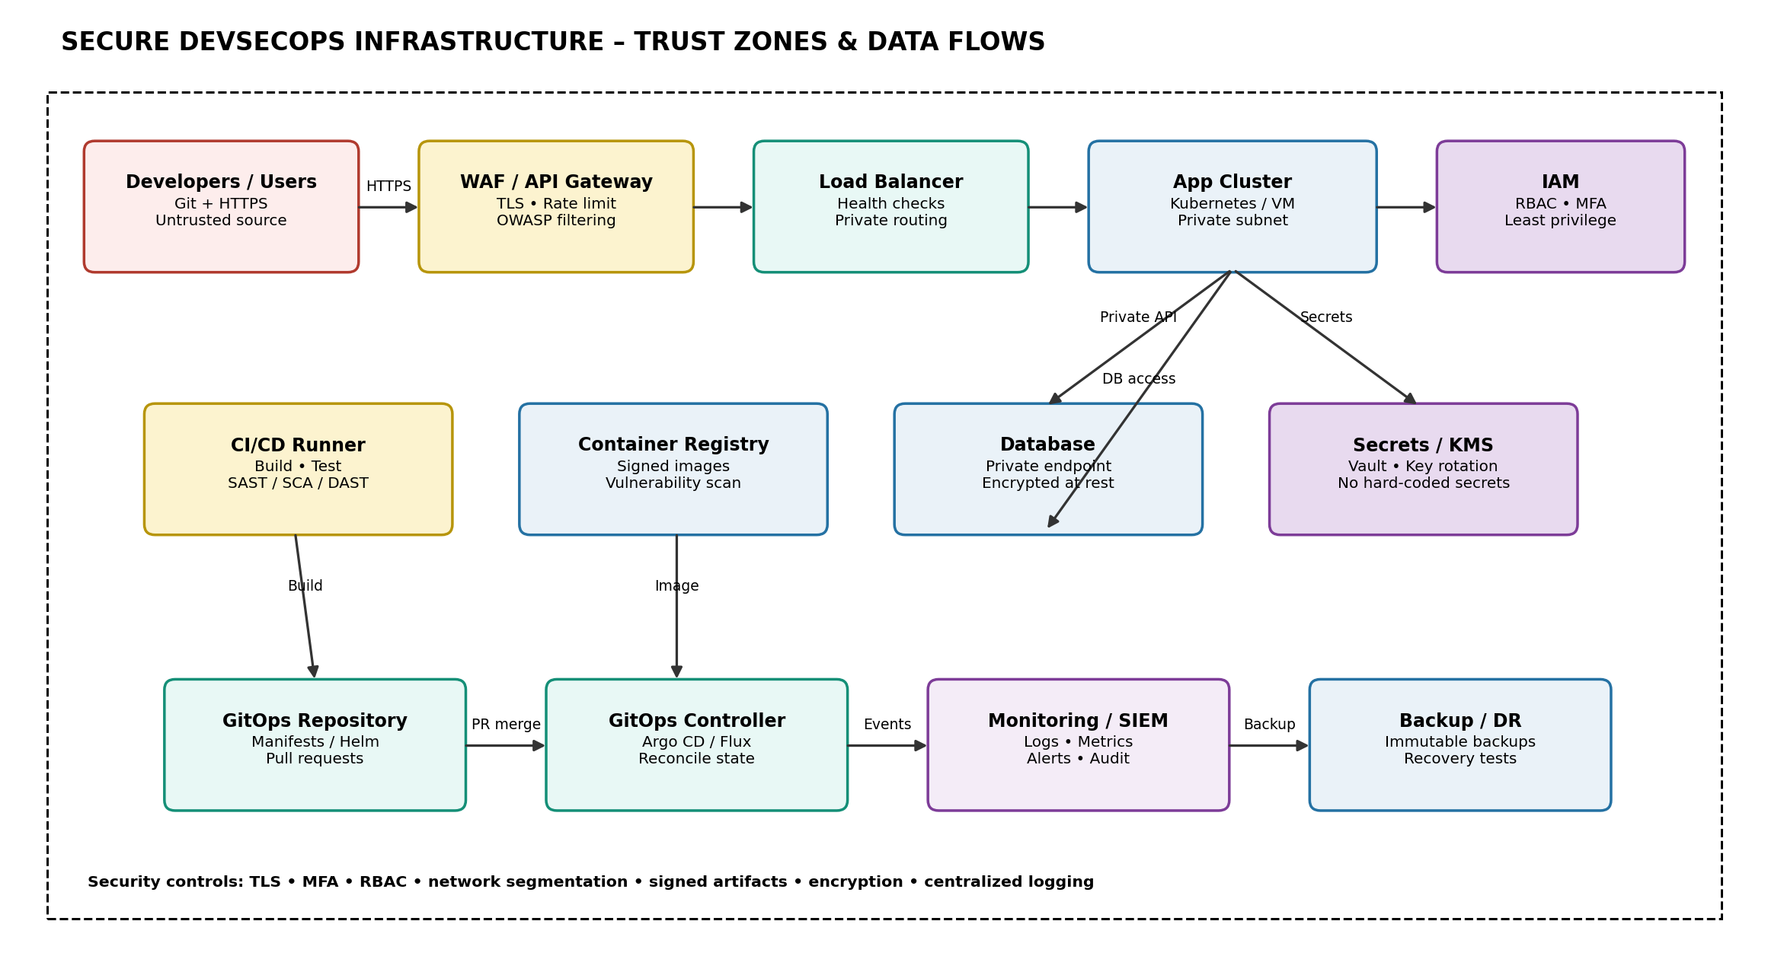
Figure 1. Secure DevSecOps infrastructure showing trust zones, deployment components and security controls.

3. Architecture Components and Responsibilities
Component | Zone | Purpose | Security
Developer / User | Untrusted | Writes code or consumes service | MFA, HTTPS, device hygiene
WAF / API Gateway | Edge | Filters and routes external requests | TLS, rate limiting, OWASP rules
Load Balancer | Edge/App | Distributes traffic | Health checks, private routing
Application Cluster | Private App | Runs business logic | Network policies, hardened images
IAM Provider | Identity | Authentication and authorization | SSO, MFA, RBAC, OIDC
CI/CD Runner | Build | Compiles, tests and scans code | Ephemeral runner, secrets isolation
Container Registry | Supply Chain | Stores release images | Image scan, signing, access control
Database | Private Data | Persistent application data | Encryption, private endpoint, backups
Secrets / KMS | Security | Keys and application secrets | Vault, rotation, audit
GitOps Repository | Management | Desired deployment state | Branch protection, PR review
GitOps Controller | Operations | Reconciles cluster state | Scoped service account, audit
Monitoring / SIEM | Security Ops | Collects events and alerts | Central logs, restricted access
Backup / DR | Recovery | Recovery from failure/ransomware | Immutable encrypted backups

4. Trust Boundaries and Secure Data Flows
- Internet-to-edge boundary: only HTTPS enters the public endpoint. WAF/API Gateway rejects malformed, malicious and rate-abusive requests.
- Edge-to-application boundary: load balancer forwards validated requests to private application instances; application servers have no public IP addresses.
- Application-to-data boundary: database access is limited to the application identity/security group and uses encrypted connections where supported.
- Build-to-production boundary: CI/CD cannot directly modify production without passing security gates and approved GitOps changes.
- Management boundary: GitOps and cloud administration use separate privileged identities with MFA and detailed audit logs.
- Secrets boundary: credentials and keys are stored in a secrets manager/KMS rather than source code, container images or plain-text configuration.
The architecture follows defense in depth and Zero Trust principles: no component is trusted merely because it is inside a network.

5. DevSecOps Deployment Workflow
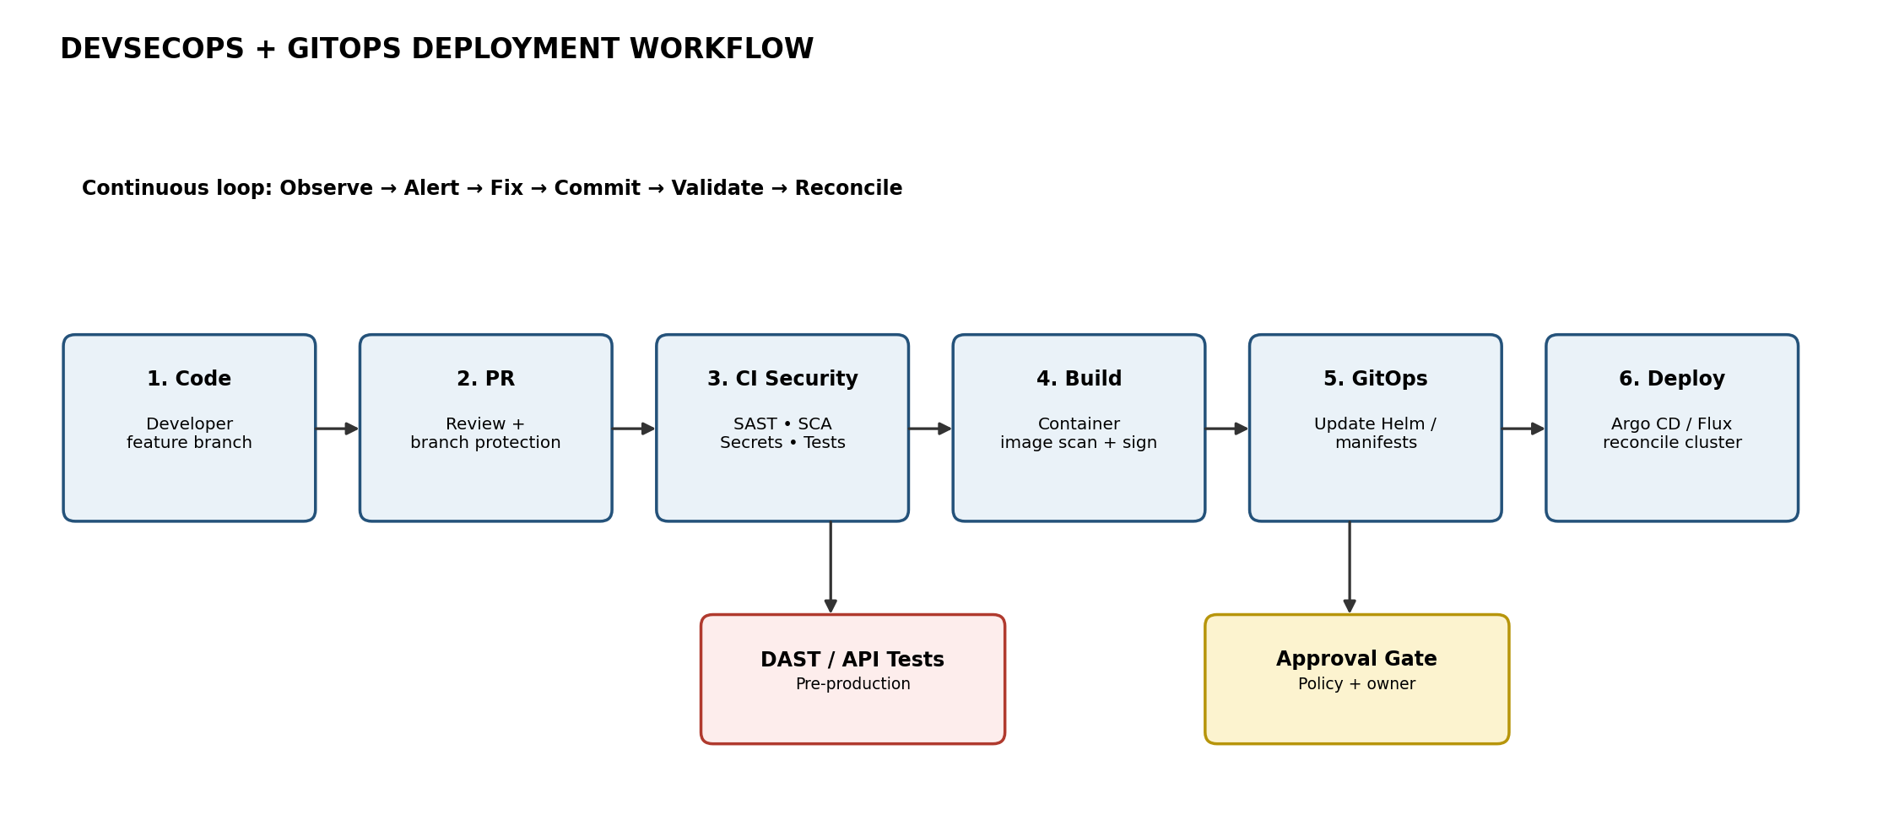
Figure 2. CI security gates followed by GitOps-based deployment and continuous reconciliation.
- Developer creates a feature branch and commits source code and infrastructure manifests.
- A pull request triggers peer review, branch protection and automated validation.
- CI runs SAST, secret scanning, software composition analysis (SCA), unit tests and configuration/IaC checks.
- The pipeline builds a container image, scans it for vulnerabilities and signs the approved artifact.
- After required security gates, the pipeline updates the GitOps repository with the desired release version.
- Argo CD or Flux detects the repository change and reconciles the target environment.
- Pre-production DAST/API tests and approval policies protect the production promotion path.
- Monitoring, audit logs and alerts continuously feed the feedback loop; remediation begins with a new controlled commit.

6. IAM Relationships
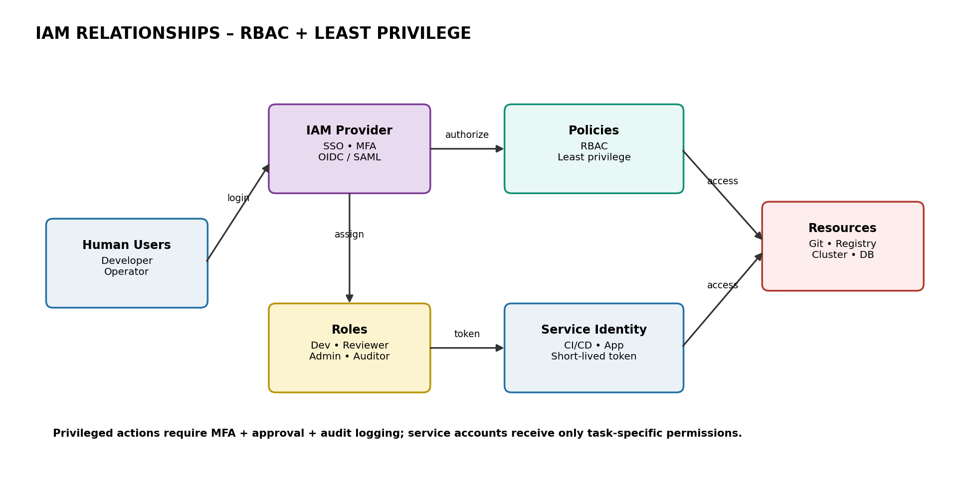
Figure 3. IAM model showing users, roles, policies, service identities and protected resources.
- Developers authenticate through SSO with MFA. Their permissions are assigned through role-based groups.
- Reviewers can approve pull requests but cannot directly change production infrastructure.
- CI/CD uses a dedicated service identity with short-lived credentials and permissions limited to build, scan and publish tasks.
- GitOps controller uses a separate service identity restricted to the namespaces/resources it manages.
- Database and secret access is granted only to the required application/service identities.
- Every privileged action is audited; periodic access reviews remove stale or excessive permissions.

7. IAM Role-Permission Matrix
Role | Code | CI/CD | GitOps | Production Data
Developer | Read/Write feature branches | Trigger pipeline | No direct access | No direct DB access
Reviewer | Review/Approve PR | View results | Approve promotion | No direct DB access
CI/CD Service | Read repository | Build/Scan/Publish | Update desired-state PR | No direct DB access
GitOps Controller | Read manifests | No build rights | Reconcile workloads | Only required app namespace
Platform Admin | Admin by exception | Manage runners | Manage clusters | Audited break-glass access
Auditor | Read audit logs | Read reports | Read deployment history | Read-only evidence

8. Infrastructure as Code (IaC) Model
- Store Terraform/CloudFormation or equivalent IaC in version control.
- Use reusable modules for network, IAM, compute, database, logging and backup resources.
- Run IaC formatting, validation and security policy checks in CI.
- Use separate state and credentials for development, testing and production.
- Protect production state and require reviewed pull requests before changes are applied.
- Record infrastructure changes in Git so the architecture is reproducible and auditable.

9. GitOps Workflow and Repository Structure
A practical repository structure is:
app/ – application source and tests
infra/ – Terraform/IaC modules and environment definitions
deploy/base/ – common Kubernetes/Helm configuration
deploy/overlays/dev/ – development overrides
deploy/overlays/staging/ – staging overrides
deploy/overlays/prod/ – production desired state
policies/ – security and compliance policies
.github/workflows/ or equivalent – CI security pipeline

10. Security Controls
Control Area | Implementation | Security Benefit
Identity | SSO, MFA, RBAC, short-lived tokens | Prevents unauthorized privileged access
Network | Private subnets, security groups, WAF | Reduces attack surface and lateral movement
Secrets | Vault/KMS, rotation, secret scanning | Prevents credential leakage
Code | SAST, SCA, secret scan | Finds vulnerabilities before deployment
Runtime | DAST, image scanning, monitoring | Detects runtime and container risks
Supply Chain | Signed images and controlled registry | Improves artifact integrity
Logging | Central SIEM and immutable audit trail | Supports detection and forensics
Recovery | Encrypted immutable backups + restore tests | Limits data-loss/ransomware impact

11. Threats and Mitigations
Threat | Potential Impact | Mitigation
Credential theft | Account takeover | MFA, short-lived tokens, anomaly alerts
Malicious commit | Vulnerable release | PR review, SAST/SCA, tests and gates
Dependency attack | Supply-chain compromise | SCA, pinned versions, signed artifacts
Container vulnerability | Runtime compromise | Image scanning, minimal images, patching
Secret leakage | Unauthorized access | Vault/KMS and secret scanning
DDoS / web attack | Availability or application compromise | WAF, rate limiting, DDoS protection
Lateral movement | Broader infrastructure compromise | Segmentation, least privilege, network policies
Ransomware | Data/service loss | Immutable backups, isolation, recovery testing

12. Monitoring, Audit and Incident Response
- Collect IAM, WAF, API gateway, CI/CD, GitOps, application, database and infrastructure events.
- Centralize logs in SIEM with restricted write/read permissions and controlled retention.
- Alert on repeated authentication failures, privilege changes, unusual deployments, critical vulnerabilities and abnormal network activity.
- Use dashboards for deployment health, security findings, availability and authentication events.
- On detection: contain the affected identity/workload, preserve logs, rotate compromised secrets, remediate the root cause and redeploy through GitOps.
- Conduct post-incident review and update policies/tests to prevent recurrence.

13. Availability and Disaster Recovery
- Run multiple application instances across failure domains and use health checks.
- Keep the database private and use automated backups with encryption.
- Store critical backups separately with immutability/versioning.
- Define RPO and RTO for the application and test restoration periodically.
- Use Git as the source of truth for infrastructure and deployment configuration so environments can be recreated consistently.

14. Expected Deliverables for Submission
- Architecture diagram source file (.drawio or DiagrammeR source).
- Final architecture PDF/export.
- Deployment workflow diagram and GitOps workflow.
- IAM relationship diagram and role-permission matrix.
- IaC files and configuration/manifests.
- CI/CD security configuration and methodology documentation.
- GitHub repository containing all supporting project artifacts.

15. Conclusion
The proposed solution integrates secure infrastructure architecture, DevSecOps security gates, IAM, IaC and GitOps into a single controlled operating model. Security is enforced from source code through deployment and runtime, while Git provides an auditable desired state. This design satisfies the Assessment Tool 2 requirements and can be implemented using Draw.io/DiagrammeR, Terraform, a CI platform and Argo CD or Flux.
STUDENT: EZHILARASI | REG. NO.: 192521187 | BTECH IT | DATE: 22-08-2026

